**PERFORMANCE APPRAISAL REPORT SELF APPRAISAL**

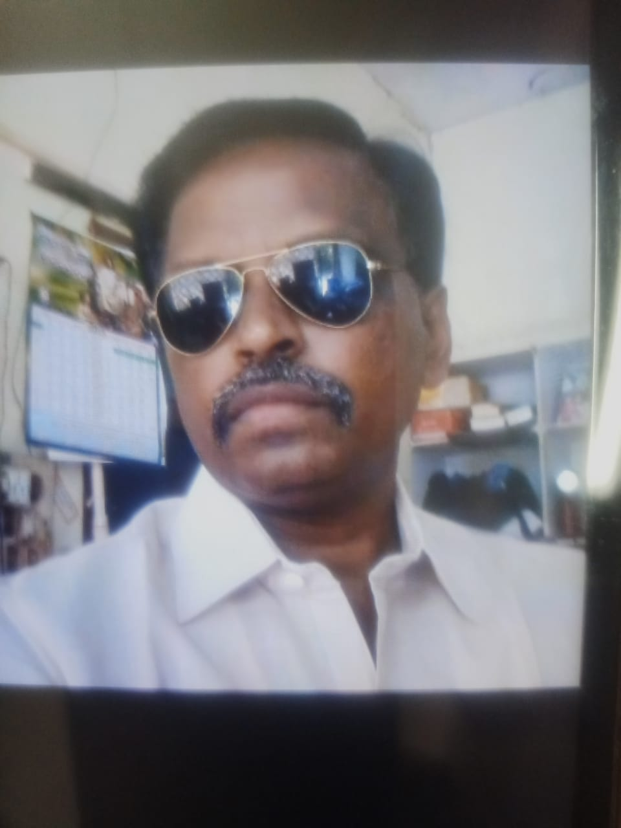

1. **GENERAL INFORMATION:**
2. Name : Dr.RAMBABU THOTAKURA
3. Date of Birth : 29.07.1968
4. Mailing Address : Department of Political Science

D.K. Govt.Degre &Pg College for

Women(A), Nellore.

1. Permanent Address : Moparru Post, Village

Amarthalur Mandal

Tenali, Bapatla District

Pin Code: 522312

1. Designation : Lecturer in Political Science
2. Department : Political Science
3. Area of Specialization : Indian Government & Politics
4. Date of Appointment : 18.07.2011
5. **ACADEMIC QUALIFICATIONS :**

|  |  |  |  |  |
| --- | --- | --- | --- | --- |
| **Exam passed** | **University** | **Subject** | **Year** | **Division** |
| Ph.D. | S.V.University Thirupati | Political Scienece | 1999 | - |
| M.A | Acharya Nagarjuna University | Political Scienece | 1991 | II |

1. **RESEARCH EXPERIENCE AND WORKSHOPS:**

|  |  |  |  |
| --- | --- | --- | --- |
| **Name of the Research Publication/Seminar/Workshop** | **ISSN/ISBN Number** | **Title of The Paper** | **Year of Publication** |
| UGC Sponsored National Seminar on Human rights | 978-935171-062-2 | Protection & Promotion of Human rights: Role of Civil Society | 2015 |
| UGC-SERO “Human Rights: Trends and Issues” | 978-93-5171-056-1 | Human Rights and Environment Issues-Aqua Culture case study of a village in Nellore district. | 2015 |
| Two Day National Seminar on Energy & Ecology | 978-93-86251-20-6 | “Energy & Ecology” | 2016 |
| National Seminar on Travel & Tourism:at Vikrama Simhapuri University, Nellore. | 978-93-85100-43-7 | “Tourism Opportunities-Case Study of Sidheswaram in Udayagiri. | 2016 |

|  |  |  |  |
| --- | --- | --- | --- |
| **Name of the Research Publication/Seminar/Workshop** | **ISSN/ISBN Number** | **Title of The Paper** | **Year of Publication** |
| UGC, APSCHE & ICSSR Sponsored Two-Day National Seminar On “ Mainstreaming Marginalized Communities in India | ---- | “ Mainstreaming Marginalized Communities in India: Challenges and Interventions” | 2017 |
| UGC Sponsored National Seminar on Governance and Government in the Residual Andhra Pradesh State | ---- | Residual Andhra Pradesh State: Issues and Challenges | 2018 |
| UGC Sponsored National Seminar on Political Parties and Indian Democracy: Current Scenario of Regional Political Parties | 978-81-950884-2-3 | “Political Parties and Indian Democracy: Current Scenario of Regional Political Parties.” | 2019 |
| UGC-SERO Sponsored National Workshop | ---- | “Human Values and Professional ethics” | 2016 |
| Internal National Conference on Human Trafficking in Asian Countries | 978-93-1071-100-1 | Human Trafficking: Causes & Measures to control | 2016 |
| Dr. Babasahed Ambedkar Marathwada University, Aurangabad. Five Day Workshop | ---- | “Classical Languages of Indian Sub-Continent” | 2021 |

|  |  |  |  |
| --- | --- | --- | --- |
| **Name of the Research Publication/Seminar/Workshop** | **ISSN/ISBN Number** | **Title of The Paper** | **Year of Publication** |
| Seven Day Online Workshop-IQAC | ---- | Work shop on 7 Assessment Criteria For NAAC Accreditation | 2022 |
| UGC-Human Resource Development Centre: Academic Bank of Credits | **----** | Academic Bank of Credits | 2022 |
| 5 Day Training Programme for Teacher’s Teaching | **-----** | “Content Delivery and Assessment Methods | 2022 |

**Refresher Courses/Orientation Courses:**

1. Participated in UGC-Sponsored Orientation Course at Andhra University, Vishakhapatnam from 19.01.2013 to 15.02.2013.
2. Participated in UGC-Sponsored Refresher Course at Sri Venkateswara University, Tirupathi from 03.06.2013 to 22.06.2013

on Disaster Management.

1. Participated in UGC-Sponsored Refresher Course at Maulana Azad National Urdu University, Telangana from 11.12.2018 to 31.12.2018 on “Political Science & Public Administration.”
2. Participated in UGC-Sponsored Refresher Course at Teaching Learning Centre, Ramanujan College University of Delhi from 26.04.2011 to 11.05.2021 on “Law Democracy and Institutions.”

**Faculty Development Programme:**

1. Participated in Faculty Development Programme on Entrepreneurship Development Training For Faculty at SVU Entrepreneurship Development Cell at S.V.University from 23.05.2016 TO 29.05.2016.
2. Participated in Faculty Development Programme on Entrepreneurship Development Training For Faculty at Mahatma Gandhi National Council Of Rural Education From 22nd to 26th August 2019.
3. Participated in Faculty Development Programme on Entrepreneurship Development Training For Faculty at Commissioner ate of College Education on “ Constitution of India, Trends in India and Western Political Philosophy, Public Policy, Foregin Policy, Corporate Scocial Responsibility and Research Advances.” From 3rd August to 07th August 2020.
4. Participated in Faculty Development Programme on Entrepreneurship Development Training For Faculty at Adikavi Nannaya University on “ Challenges and Strategies of Teaching in Post Covid-19.” From 11.05.2020 to 15.05.2020.

**(RAMBABU THOTAKURA)**

**Lecturer in Political Science**